**Experiment No. 2 : To understand Version Control System / Source Code Management, install git and create a GitHub account**

**Version Control System (VCS)**

A Version Control System (VCS) is a tool that helps developers manage changes to their code over time. It allows multiple people to collaborate on a project, track modifications, and revert to previous versions if needed. VCS prevents loss of work and makes software development more efficient.

Types of Version Control Systems:

1. Local VCS: Stores versions of files on a local machine, but lacks collaboration features.
2. Centralized VCS (CVCS): A single server stores all versions of the code, and developers pull/push changes from it (e.g., SVN).
3. Distributed VCS (DVCS): Every developer has a complete copy of the repository, allowing offline work and better collaboration (e.g., Git).

**Source Code Management (SCM)**

SCM is the practice of managing source code changes using VCS tools. It ensures that the software development process is organized, traceable, and error-free. SCM allows teams to work on different features simultaneously without overwriting each other’s code.

**Introduction to Git**

Git is a Distributed Version Control System (DVCS) developed by Linus Torvalds in 2005. It helps developers track changes, collaborate, and manage different versions of their code efficiently.

Features of Git:

* Distributed System: Each developer has a full copy of the repository.
* Branching & Merging: Allows working on multiple features simultaneously.
* Speed & Efficiency: Fast performance compared to older VCS.
* Data Integrity: Ensures code is securely stored and protected from corruption.

**Installing Git**

To install Git, follow these steps:

1. Windows: Download and install Git from [git-scm.com](https://git-scm.com/).
2. Linux (Ubuntu/Debian): Run: sudo apt update && sudo apt install git
3. MacOS: Run: brew install git

Verify the installation by running: git –version

**Introduction to GitHub**

GitHub is a cloud-based platform that provides remote storage for Git repositories. It allows teams to collaborate, manage projects, and contribute to open-source software.

Features of GitHub:

* Remote Repository Hosting: Store and share code securely.
* Collaboration Tools: Pull requests, code reviews, and discussions.
* CI/CD Integration: Automate deployment and testing.
* Issue Tracking & Project Management: Organize and track progress.

Creating a GitHub Account

1. Visit [GitHub](https://github.com/).
2. Click “Sign Up” and fill in the required details.
3. Confirm your email and set up a profile.

Once your GitHub account is ready, you can create repositories, push code, and collaborate with others. Git and GitHub together make software development smoother, organized, and efficient.

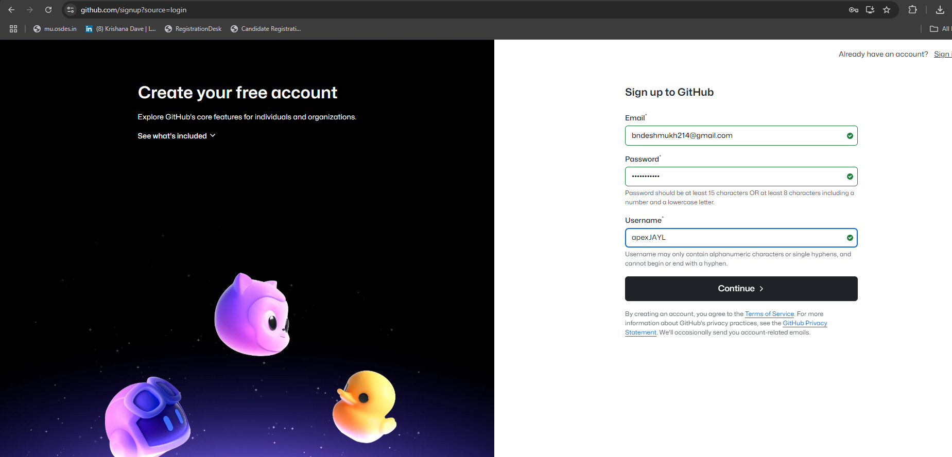



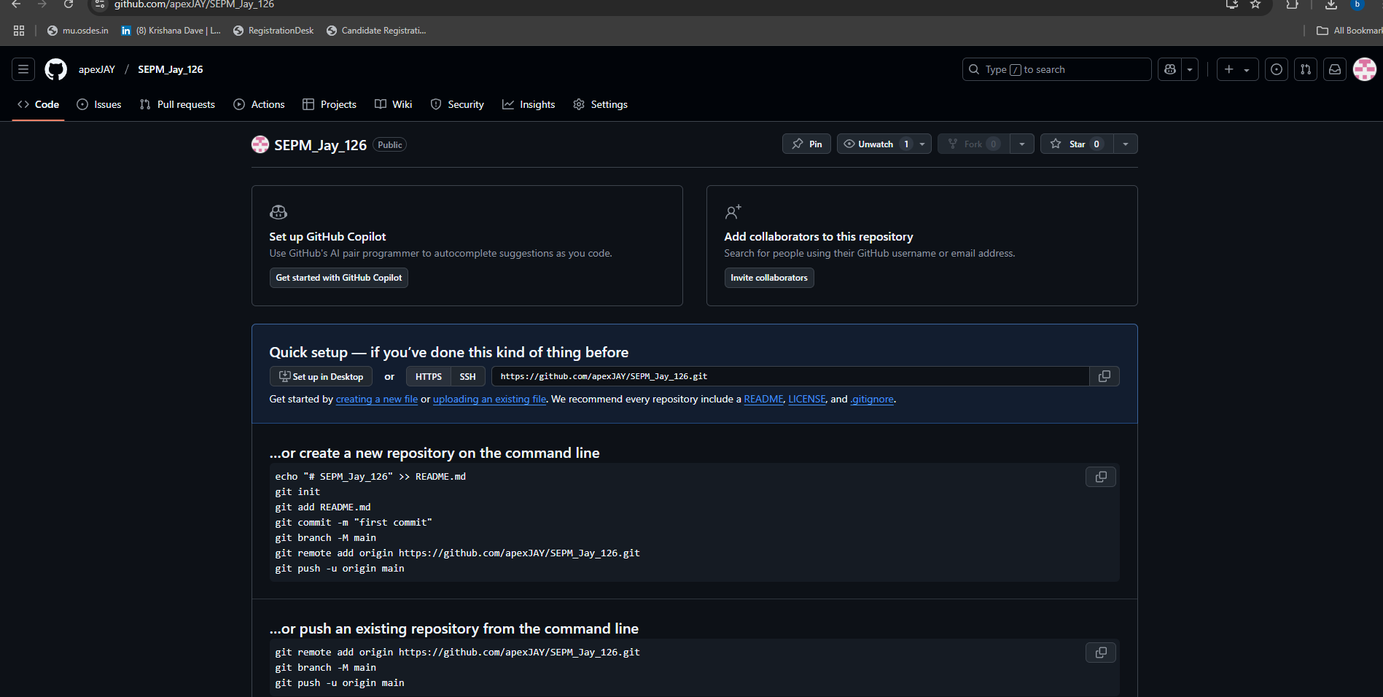

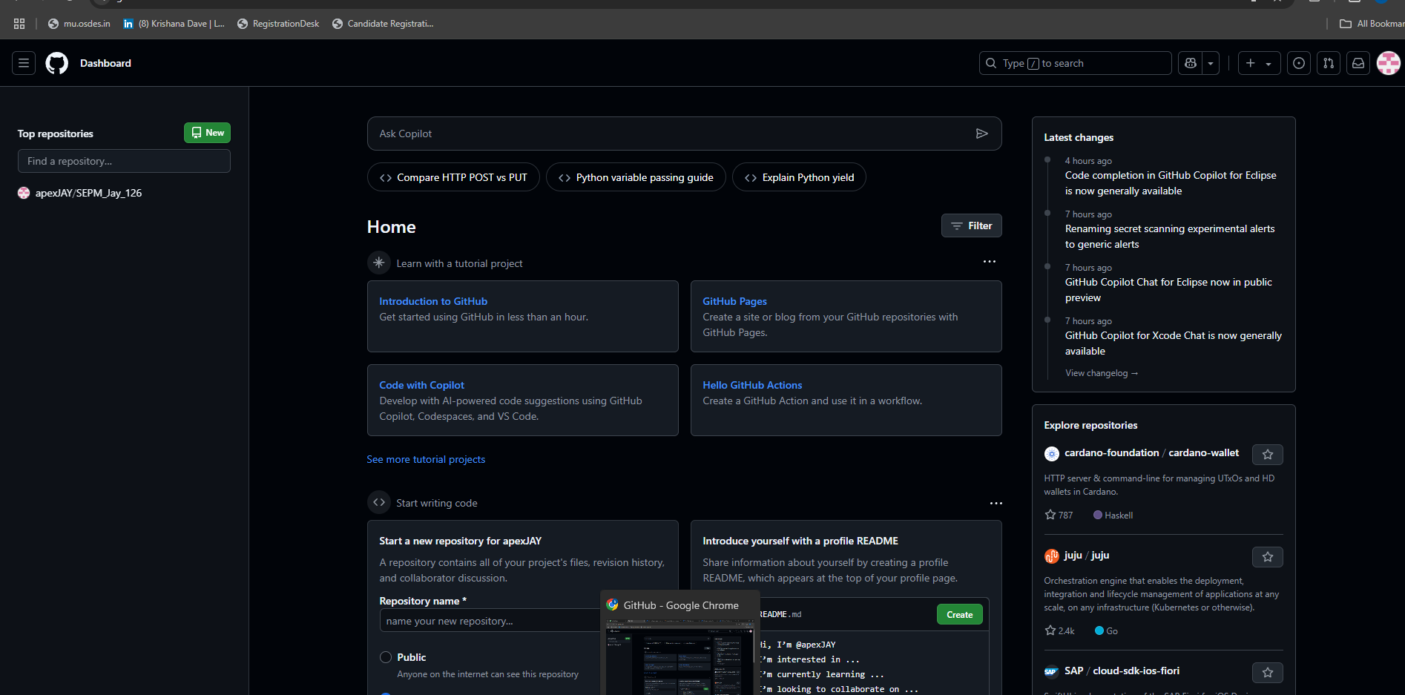

**Conclusion :** Thus we have successfully created github account.